**Worldwide Sporting Goods – Your One Stop Sports and Leisure Source**

**Our priorities:**

Best Products

Best Prices

Best Service

**Products Distributed by Worldwide Sporting Goods**

****Worldwide Sporting Goods manufactures the finest equipment, clothing and supplies available. For items not produced by Worldwide Sporting Goods, we stock only first quality merchandise supplied by leading Sporting Goods Manufacturers

**Our primary product lines are:**

* Equipment
* Team Supplies
* Clothing
* Memorabilia

**Equipment**

We produce a full line of baseball, basketball, fishing, football, hockey, lacrosse and soccer equipment. All equipment comes with a one year limited warranty. (See specific item warranty for details.)

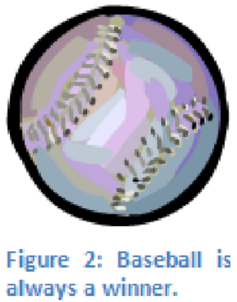Worldwide Sporting Goods also distributes tennis and racquetball equipment manufactured by Olympic Racquet Company, and skating equipment produced by National Skates, Inc.

**Clothing**

We manufacture our own high quality clothing and uniforms endorsed by many professional athletes. Worldwide Sporting Goods uses only the best material fabric in creating our complete line of sportswear.

**Supplies**

Our selection of game-related supplies (tape, mouth-guard, ice-packs,

ointment, etc.) is almost unlimited.

Memorabilia

In addition to equipment, clothing and sports supplies, Worldwide Sporting Goods stocks a tremendous selection of baseball cards, posters and pictures (some autographed) and commemorative programs.

**Benefits of Worldwide Sporting Goods as Your Primary Sports Equipment Supplier**

There are many reasons for stocking your store with Worldwide Sporting Goods products.

Worldwide Sporting Goods, one of the largest manufacturers and distributors of sporting goods worldwide, offers:

1. highest quality products
2. Superior selection
3. Extended product warranties
4. competitive pricing
5. Friendly customer support
6. Stock control
7. Cooperative advertising agreements
8. well-trained, knowledgeable sales staff